Part 2: Inter-Symbol Interference due to multi-path channels:

Method 1 using adaptive filter:

Generation of the main signal

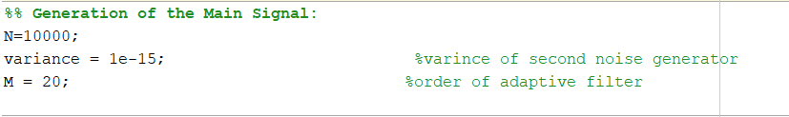

In this part we generate the BPSK modulated digital signal by generating a random signal from zeros and ones and convert the 0 to -1

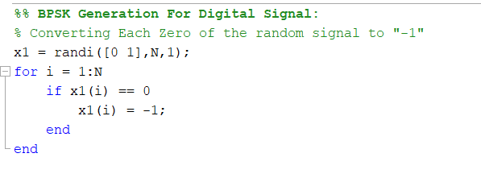

Generating the noise

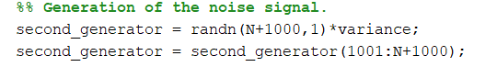

Generation of the multipath channel

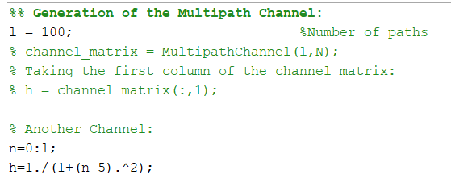

In this part we will pass the input signal through the multipath channel then add the noise signal to the output signal

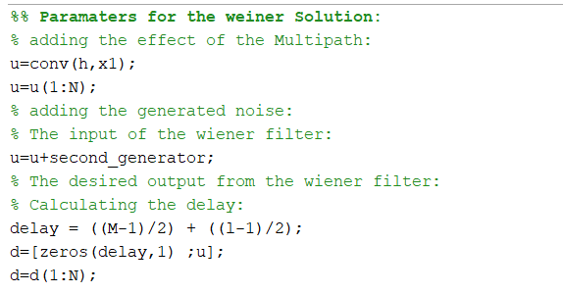

Receiver : In this part we will pass the received signal through the weiner filter to remove the effect of the multipath channel 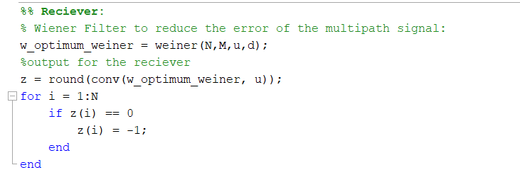

Calculate the BER :



Plotting the weight of the filter

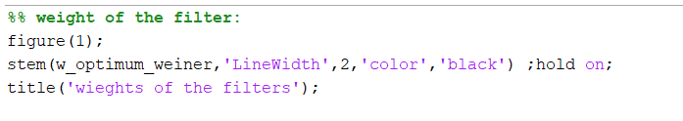

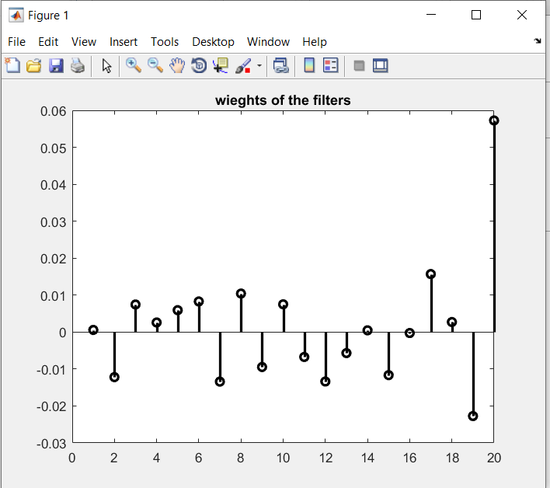

Plotting the frequency response of the channel

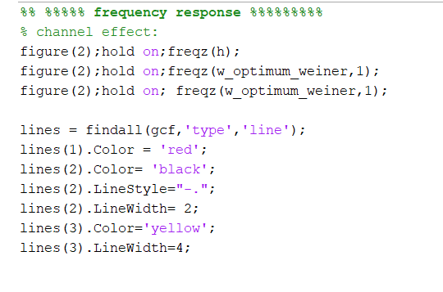

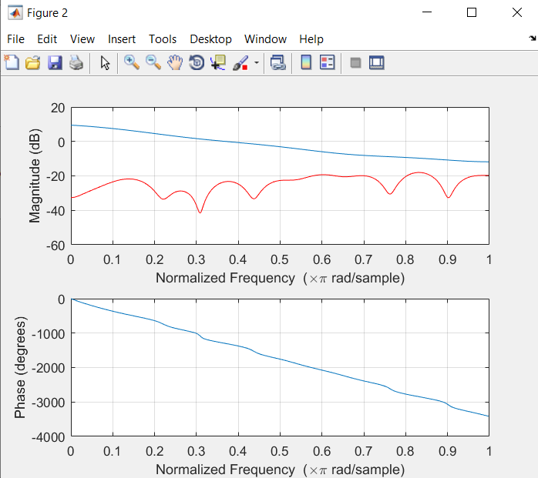

The weiner function:

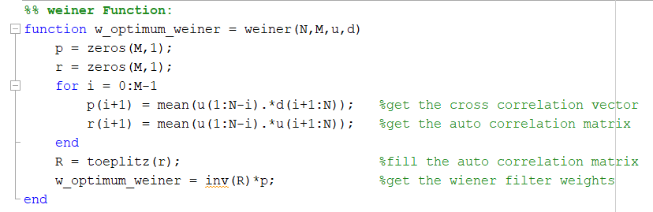

The BER function:

In this part we Compare the received signal with the original signal to detect the errored bits

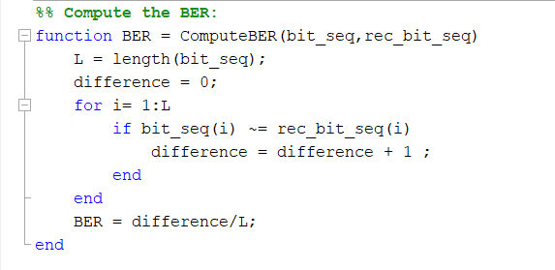

Another way to implement the multipath channel

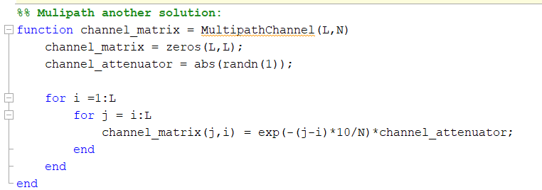

Method 2: using the matrix y=HX+N

In this part we generate the transmitted signal

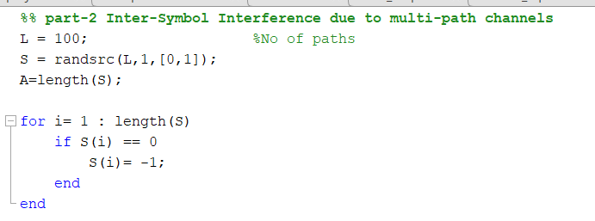

Then generating the coefficient matrix H as a complex gaussian with zero mean and variance 1 and generating the noise signal as AWGN

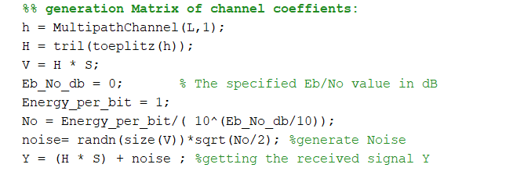

In this part we estimate the transmitted signal from the received on using the matrix equation x=inv(H)\*(y-N)

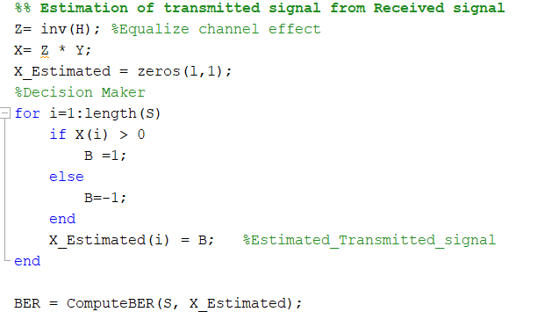

Then repeating the calculation of BER to plot it with the Eb/No

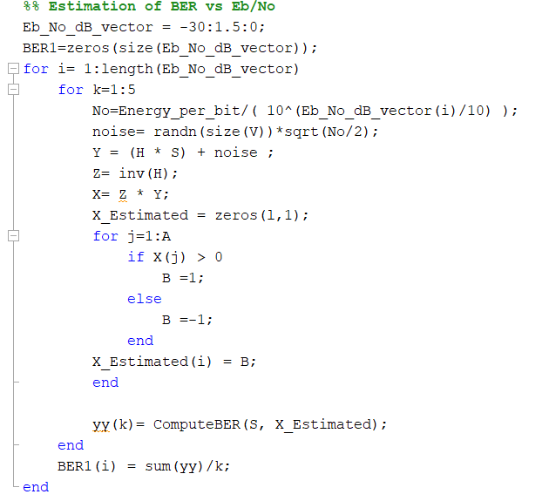

Plotting BER vs Eb/No

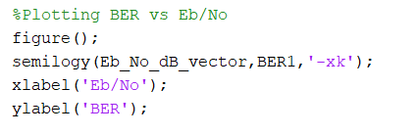

The details of the multipath channel function

